Circuits with opamps and resistors
Determine the gain (vout/vin) for circuits 001 and 003. Compute vout in terms of v1, v2, v3 for circuits 002 and 004.
- Write your answers in the table shown.
- On a separate page, show your work for each problem.
- Write “unknown” for circuits whose current/voltage cannot be determined.
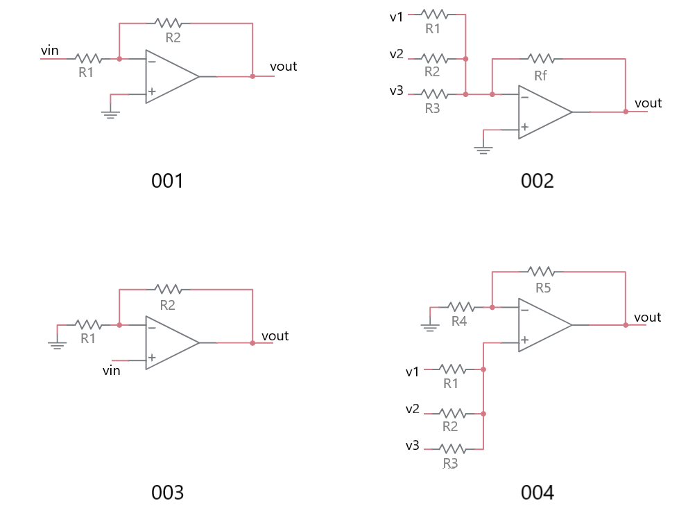

Circuit | Gain or vout
001
002
003
004

Circuits with opamps and resistors
Determine the gain (vout/vin) for the following circuits.
- Write your answers in the table shown.
- On a separate page, show your work for each problem.
- Write “unknown” for circuits whose current/voltage cannot be determined.

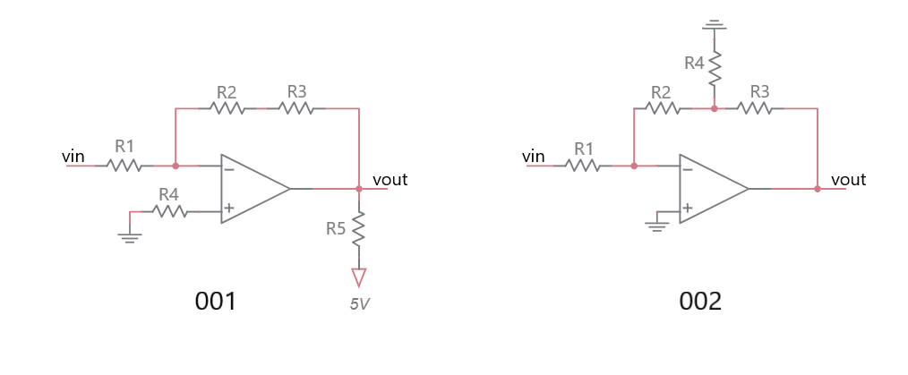
Circuit | Gain
001
002

Circuits with opamps, capacitors and resistors
For each of the circuits, plot vout in terms of the input signal given.

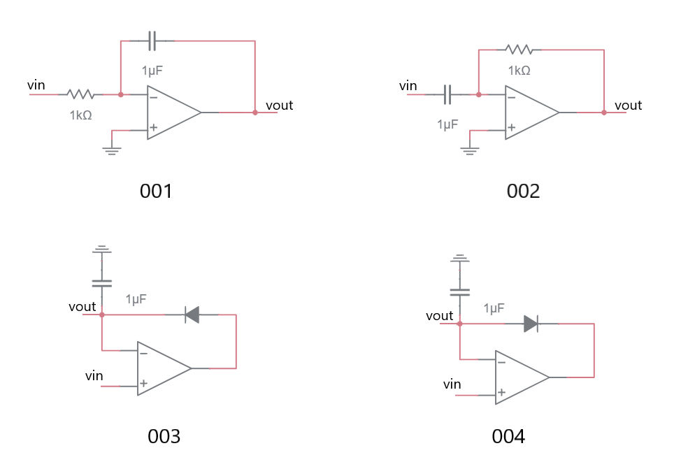

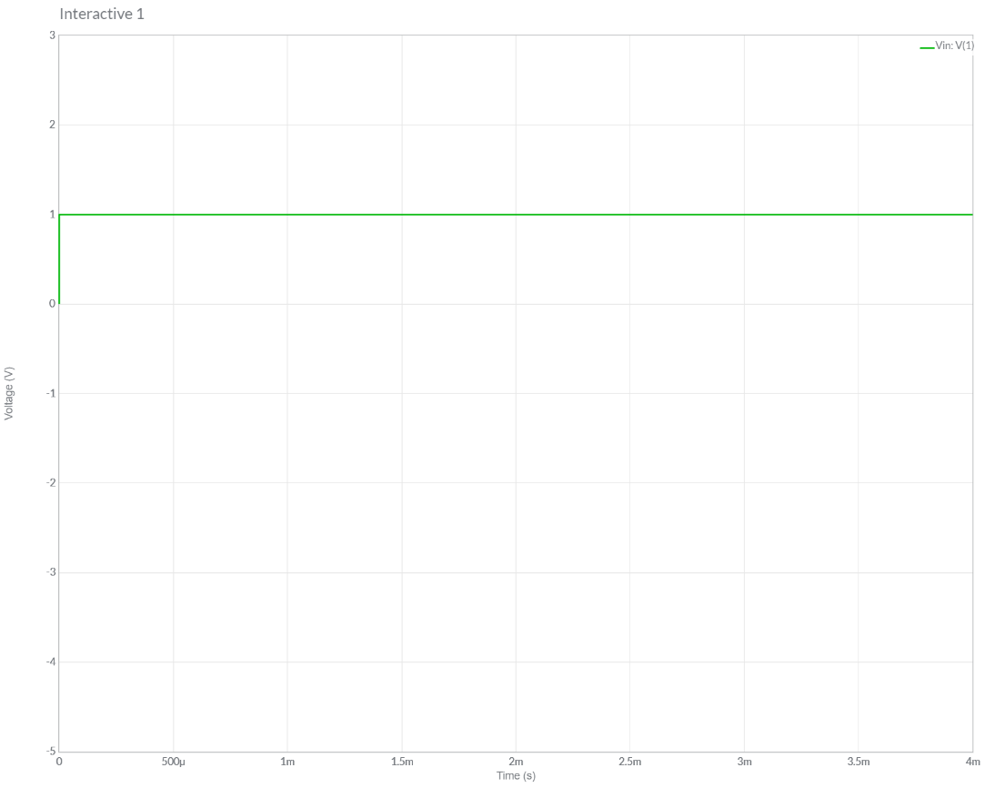
Plot vout for the circuit labeled 001.
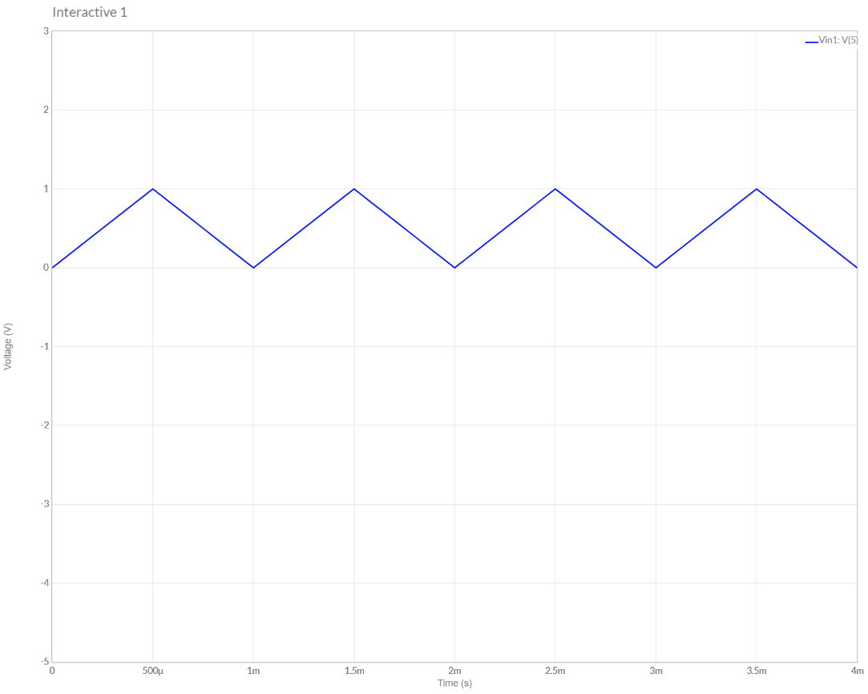
Plot vout for the circuit labeled 002.

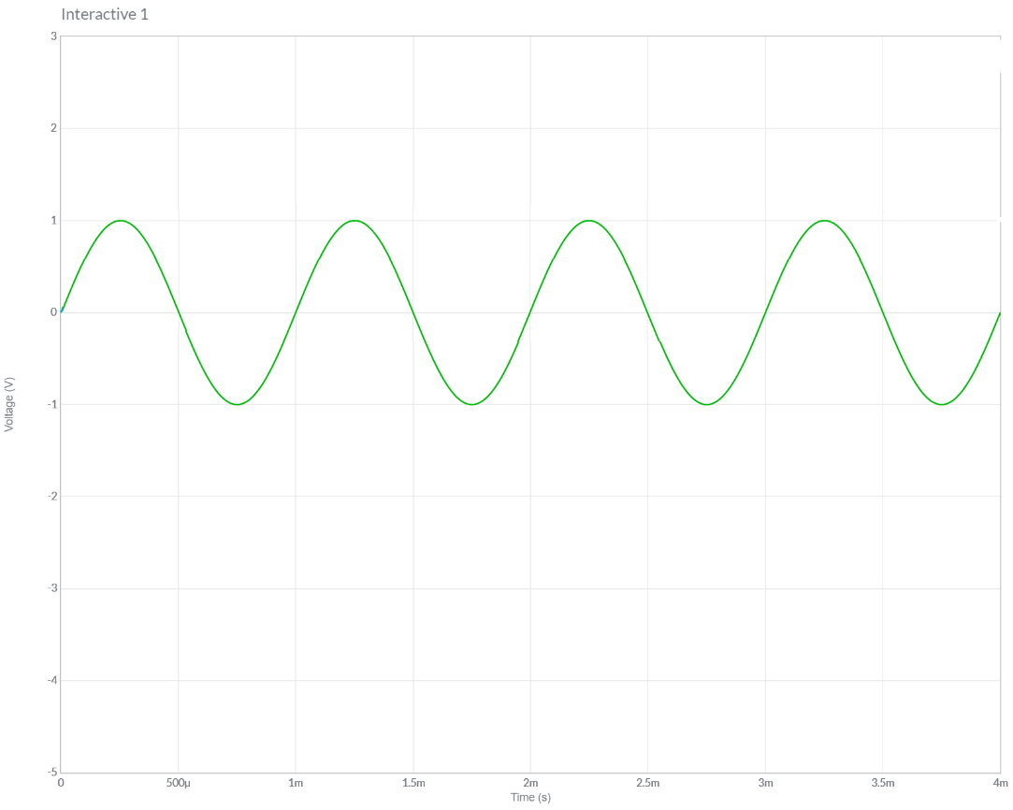
Plot vout for the circuit labeled 003.

Plot vout for the circuit labeled 004.

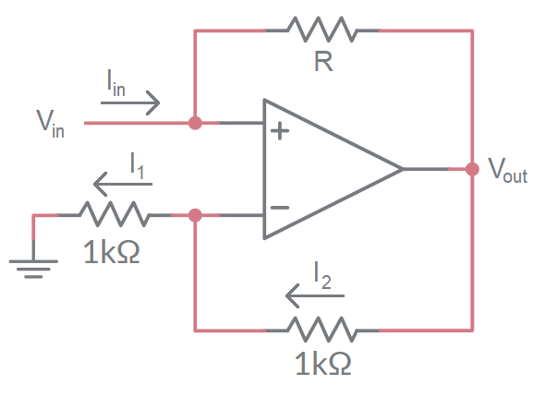
Practical Application - Negative Impedance Converter
The negative impedance converter (NIC) is an active circuit which injects energy into circuits in contrast to an ordinary load that consumes energy from them. Let’s analyze the NIC shown to better understand what this means. Fill in your answers in the boxes provided.
- Assume that the negative feedback makes the inverting and non-inverting inputs of the opamp equal. What is the voltage on the non-invering input of the opamp?

- Use Ohm’s Law to determine the current I₁.

- Use KCL to determine the current I₂.

- Use Ohm’s Law to determine V_{out}. Express your answer in terms of V_{in}.

- Write the Ohm’s Law expression for the resistor R. Take care with the passive sign convention and substitute Vout with the expression you got in step 4.

- Solve the equation in step 5 for V_{in}/I_{in}.

